How to dismount antenna from extender when sending antenna (DC) for RMA process.
Starting point:
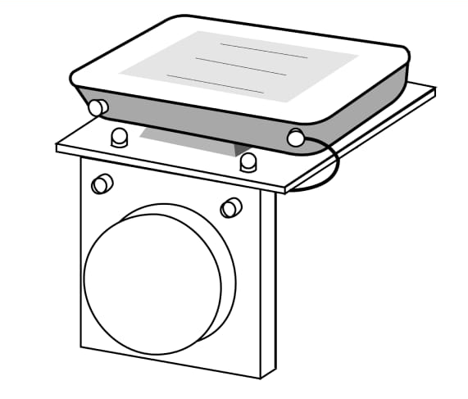
1)
Dismount all cables (internet and power, or single internet (POE))
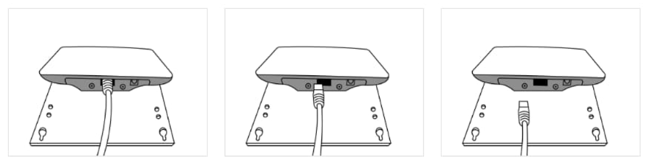
2)
Unscrew the external antenna cable from antenna (Dynamic Communicator) socket
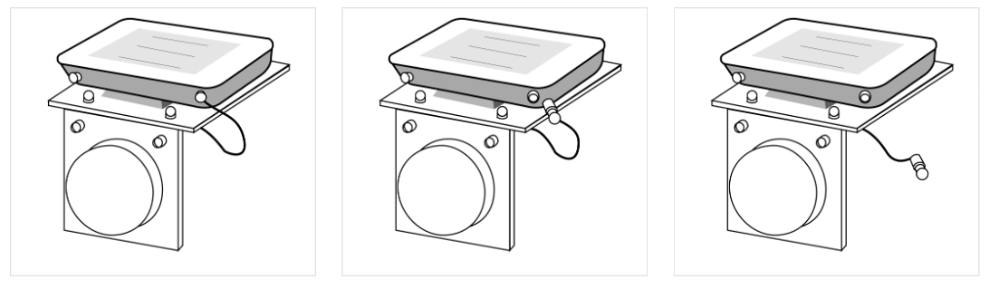
3)
Slide antenna (Dynamic Communicator) away from external antenna
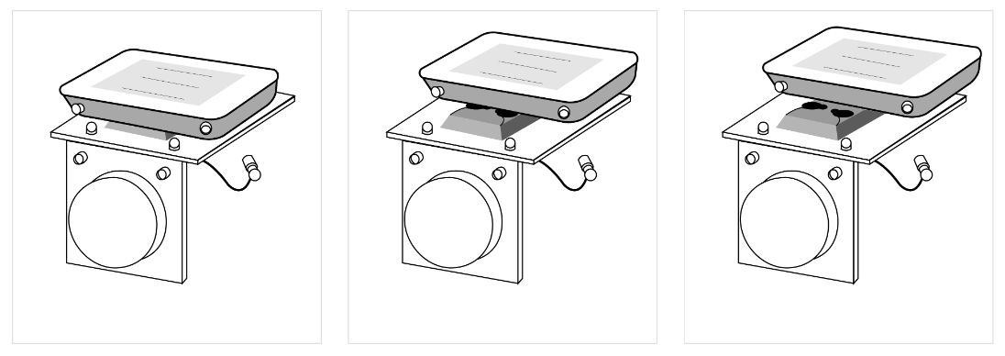
End result (The antenna (Dynamic Communicator is separated from the external antenna):
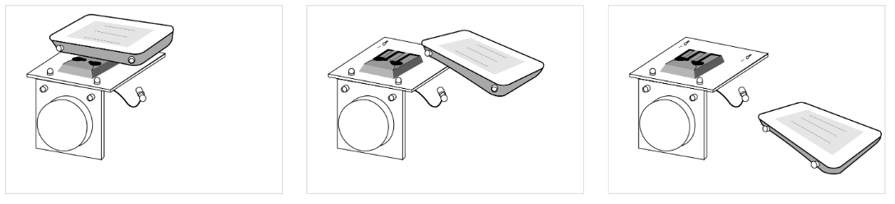

Now send the antenna (Dynamic Communicator) for RMA processing.
Note: Please ensure correct and safe packaging.

