This is a User guide about Media providers in your new Breece Cloud ESL system.
To Use the system, you must open a Browser and log in.
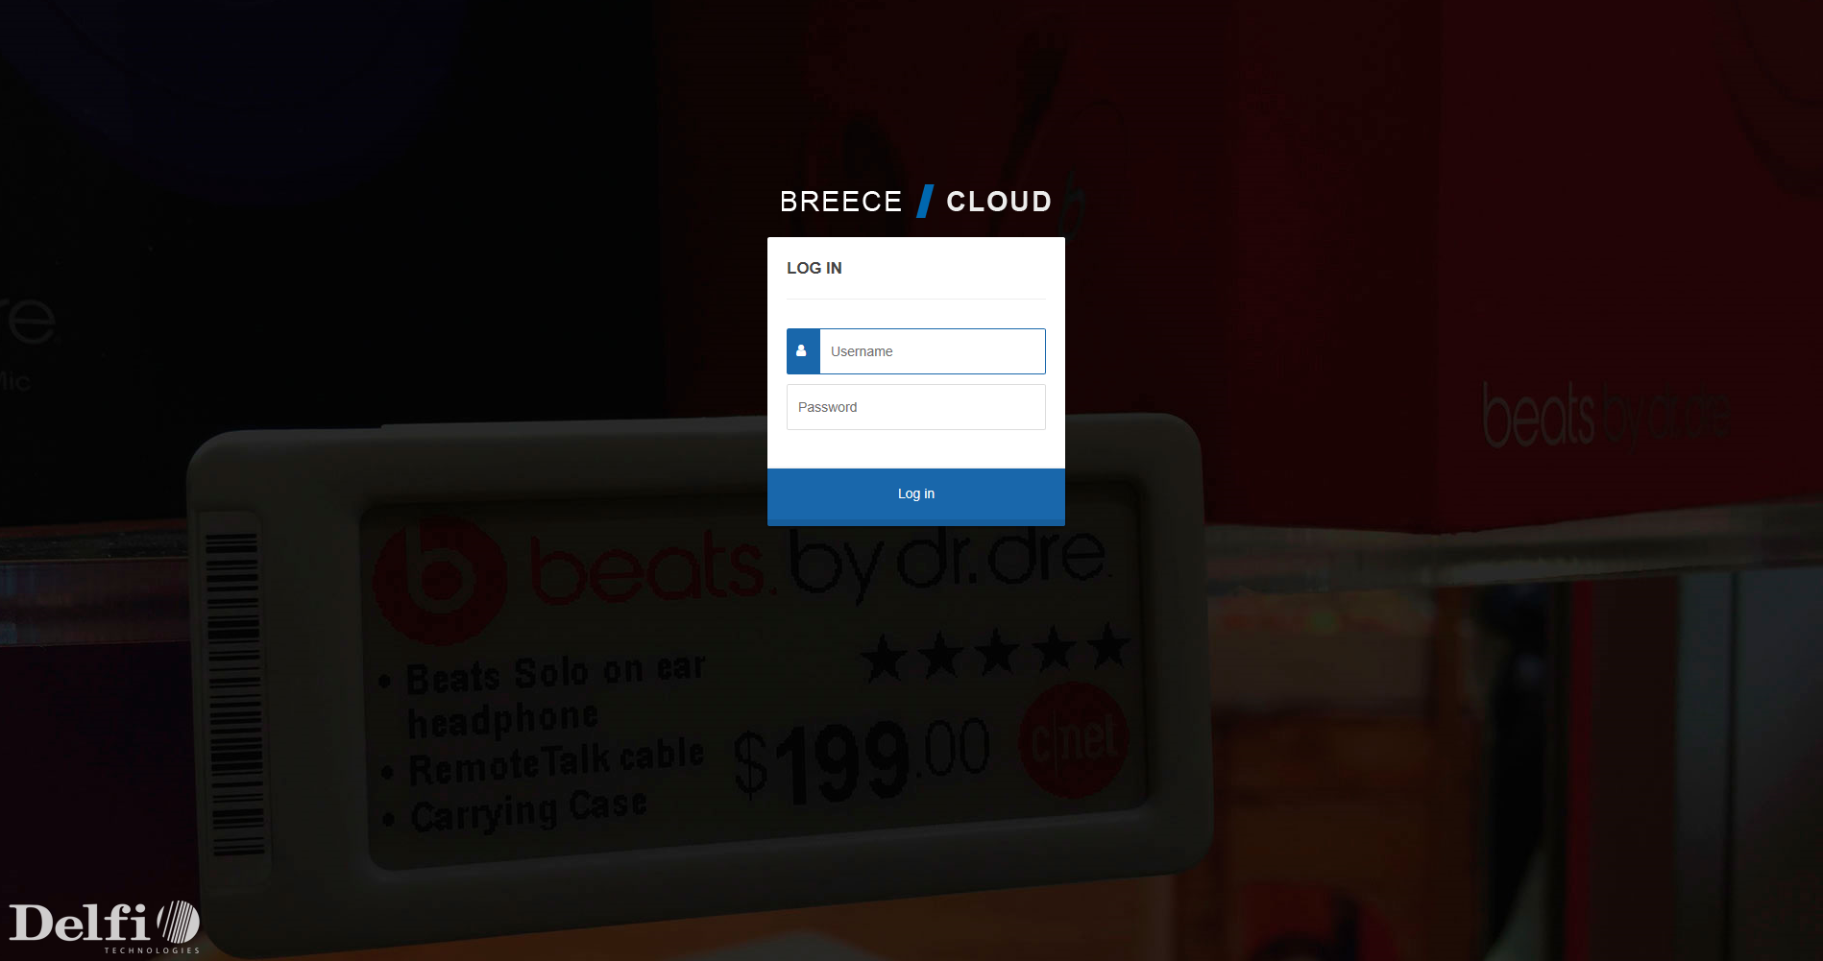

The Media button contains Media List and Media Providers
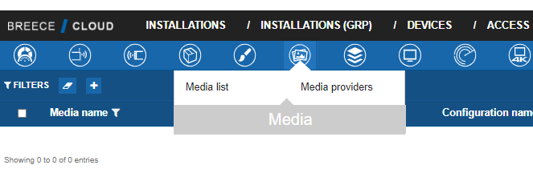

The Media List is a list of pictures, that can be used in the layout to the displays. For example a logo can be used. Picture file extensions can be *.bmp, *.jpg, *.png.
We cache pictures and they are shown until deleted. To delete pictures, mark the line of the picture, click picture detail and delete.
To download a picture, mark the line, right click on the picture you choose to get and choose Save Picture as.

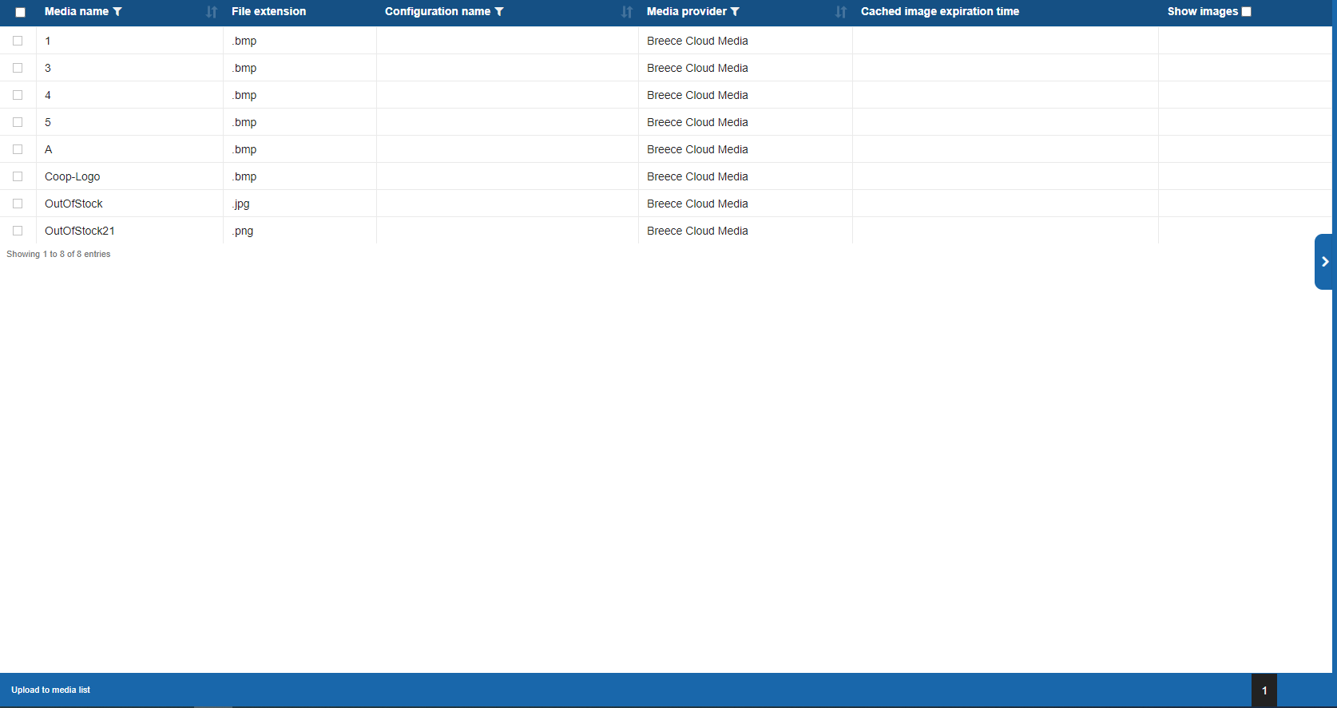

Media Providers:
This is for external Media banks, and can be used with our Digital Signage solution Vision 4K

Here it is possible to select a predefined provider or add a new one:
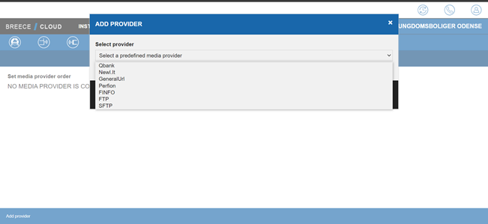
If the Media provider is not predefined, it is possible to add new ones. All Media Providers has to be certified to obtain connection.
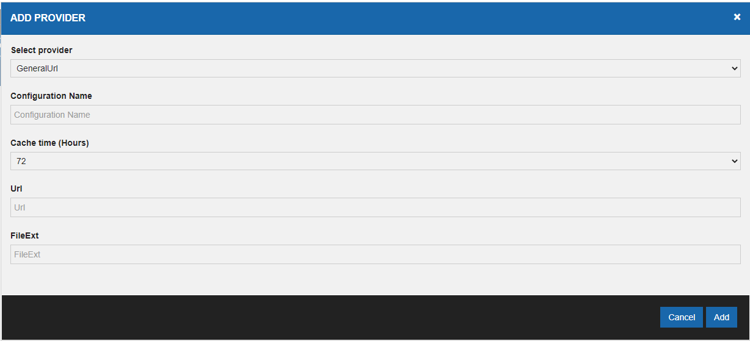
Select Provider: This is the general URL to the media provider.
Configuration Name: The Name for the Media provider configuration. Typically named the Media provider’s name.
Cache time (hours): This is the time that the cloud caches the media.
URL: Specific URL to Media Bank.
FileExt: Here file extensions can be specified to allow search of certain files to be used.

Here is an external media provider example
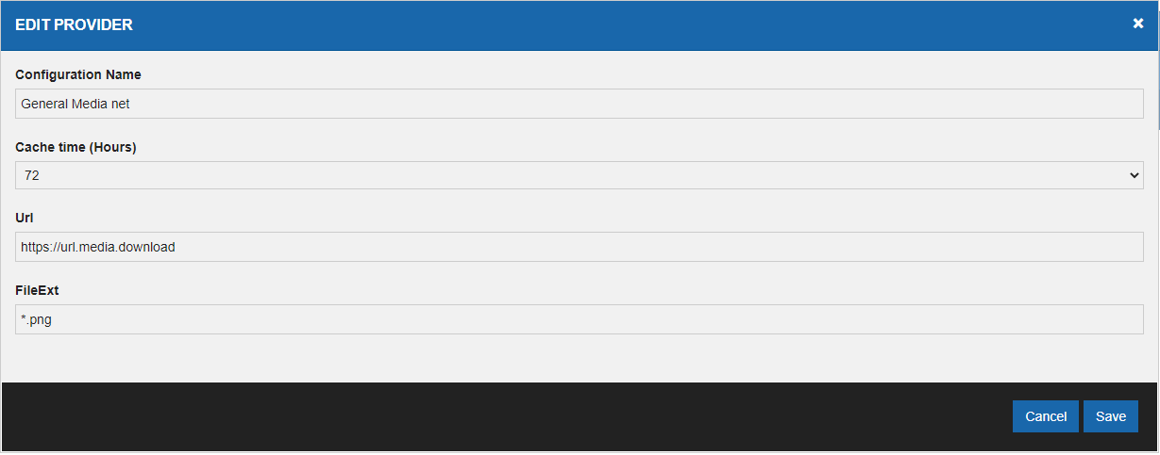

Her is an example for a predefined Media Provider:
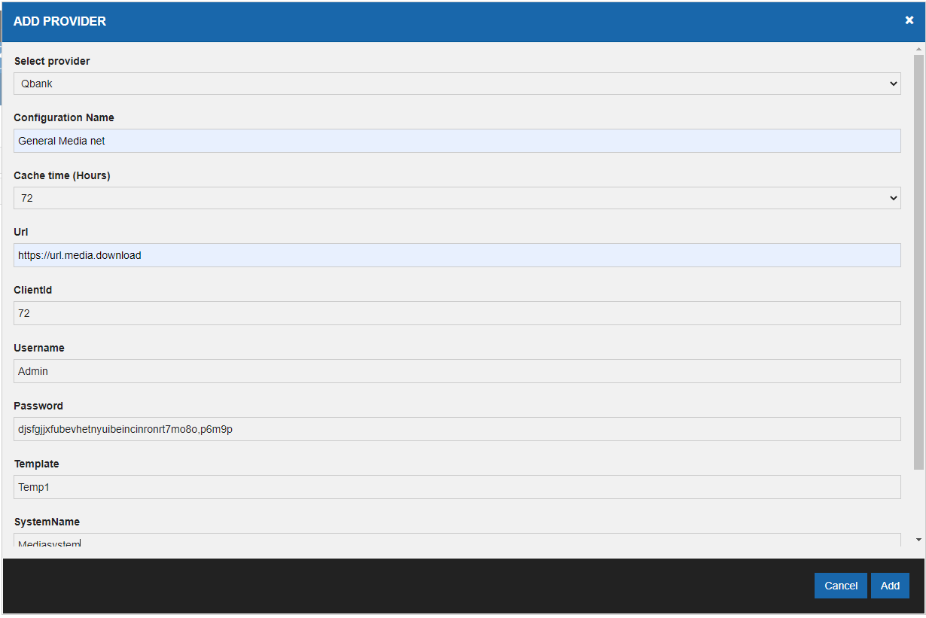

It is also possible to connect to a ftp or sFTP site and define the FTP/sFTP settings:

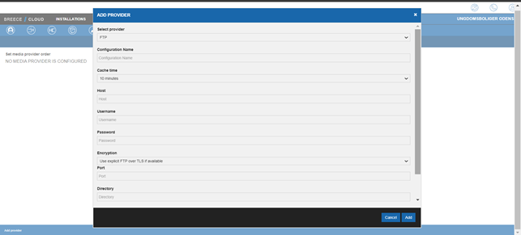

- To do so, choose the Media Provider as ftp or sFTP.
- Give the provider an installation name.
- Choose a cache time ( Default 10 minutes )
- Provide the ftp/sFTP sites ip adress ( Hostname )
- Provide the username for the ftp/SFTP site
- Provide the password for the ftp/SFTP site
- Choose the incryption to use
- Choose the port to use ( Default ftp port = 21 Default sFTP port = 22 )
- Choose the directory on the ftp/sFTP server where the medias are.
- Choose what file extention whis is allowed.

It is possible to have one or more Media providers attached to an installation. It is also possible to rearrange the order of the media providers. We serch for media at the primary provider first and if not found then the second.

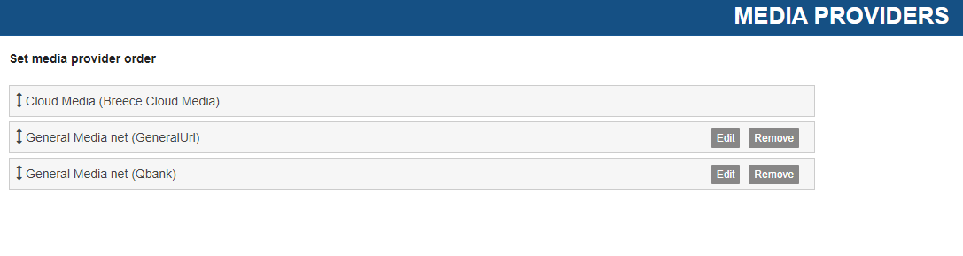It is possible to inherit media between media providers!
To make this happen the configured media providers need to be inherited all the way to the top installation group
So, if there is defined a media provider on the top group, and no media providers have been configured on any of the levels below (installation group or installation) we should use this.
So if there is ANY media providers defined on installation level we will use ALL media providers on the installation level but NONE of the providers configured on any of the installation groups it is part of.
If no media providers is defined on installation level, we will look to the next level which is the installation group.
If no media providers is defined on installation group, we will look to the parent group of the installation group.
We should look recursively back to the top group, and stop on the first group with any media providers defined.
Any images found using a media provider is cached on the same level. So, images fetched from a media provider on installation is saved on installation. Images fetched from Group is saved on that group.
The most specific will always have precedence.
Example:
We have this hierarchy:
Coop (Top Group)
- Coop Nord (Group)
- Mega (Group)
- Mega Oslo (Installation)
If the installation (Mega Oslo) has the media provider configured, we will use the media providers from there. If the media provider is only configured on the top group (Coop) we will use the media providers here.

